CLIP 模型

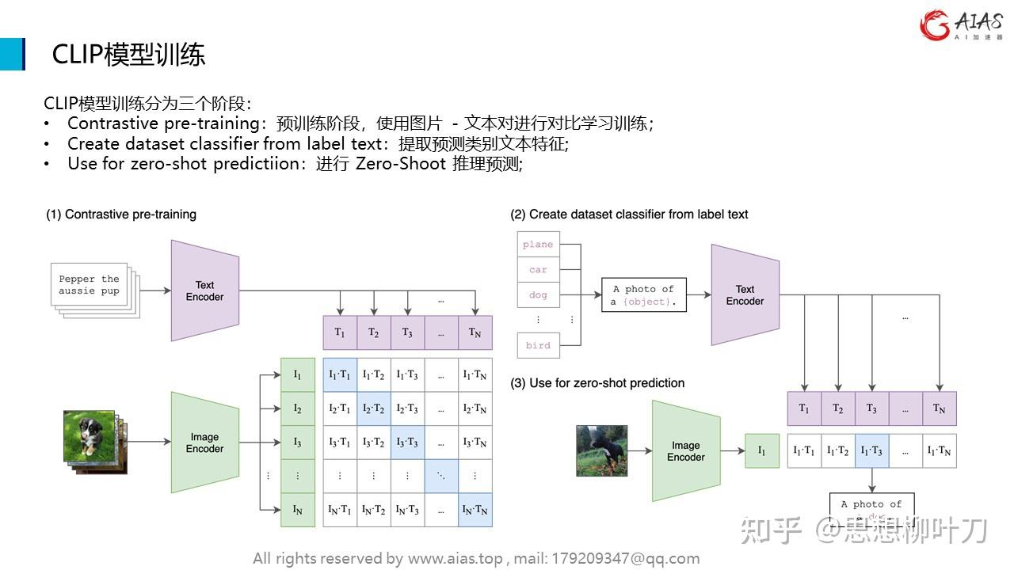

- 预训练
image_encoder 图像的神经网络架构（ResNet, Transformer...）
text_encoder 文本信息的神经网络架构（CBOW, BERT ...）
在一个共同的多维空间(joint multi-modal space)，把text与image嵌入 - 相关的彼此靠近，不相干的远离 - 计算cosine相似度
- 提取预测类别文本特征
（3）zero-shot预测

Introduction

Why our company

Why this role

Proudest project

Challenge

During my most recent internship, I was working with AI Smart Search project. This project was

What do you know about us?
Innovation
Telecommunication
I admire Bell’s 5G initiatives and want to contribute to scalable solutions
Your AI-driven analytics team aligns with my experience in machine learning

Conflict in a team project (collaboration and outcomes)

Face a problem

Of course. This is an excellent project. Here are a few versions of an introduction, ranging from a concise summary to a more detailed breakdown suitable for a resume or interview.

### 1. Elevator Pitch (Very Short & Impactful)

"I designed and built the AI Smart Search API for our video surveillance platform. It allows users to search their footage using natural language—like 'find the person in the red car'—instead of scrolling through hours of video. The system supports 19 languages and uses detailed logging to continuously improve its accuracy and speed."

### 2. Short Paragraph (For a project summary or cover letter)

"The AI Smart Search project is an intelligent search layer integrated into our video surveillance application. It empowers users to quickly locate specific events within their footage using descriptive text queries. My key contributions included architecting and developing the core Python API to handle over a thousand multilingual daily queries, and implementing a Redis-based analytics system. This system tracks user search patterns, which enabled a 25% faster response to performance anomalies and provided critical data for the AI team to improve model accuracy through targeted error analysis and dataset refinement."

### 3. Detailed Breakdown (Ideal for your Resume/LinkedIn)

**Project:** AI-Powered Smart Search for Video Surveillance

**Description:** Developed a natural language processing (NLP) system that allows users to perform intuitive, text-based searches on their surveillance video archives (e.g., "white truck reversing at night"). This transforms a manual review process into an efficient, intelligent querying system.

**Key Contributions & Achievements:**

* **Full-Stack API Development:** Designed and implemented the core **Python** API for the AI Smart Search feature, enabling complex query processing and supporting **19 languages** to serve a global user base, successfully scaling to handle **1,000+ daily queries**.
* **Performance Analytics System:** Engineered a high-performance logging and analytics system using **Redis** to capture real-time user search behavior and system performance metrics. This data pipeline **improved anomaly detection speed by 25%**, ensuring higher system reliability and a better user experience.
* **AI Model Support & Optimization:** Conducted comprehensive error analysis and prepared tailored datasets for model retraining, directly supporting senior AI engineers in improving core algorithm performance. Delivered detailed reports on precision and recall metrics to guide the product's strategic development.

---

### How to Talk About It in an Interview:

"Sure, I'd be happy to talk about the AI Smart Search project. The goal was to solve a major pain point for our users: finding a specific moment in days of video footage is like finding a needle in a haystack.

My primary role was to build the bridge between the user and the AI models. I designed the Python API that takes a user's natural language query—in one of 19 languages—and prepares it for processing by the backend AI engines that do the actual video analysis.

I knew that understanding *how* users were searching was critical for improvement, so I built a custom logging system using Redis. Its speed was perfect for capturing high-volume search data without slowing down the user experience. This wasn't just for metrics; it was a diagnostic tool. By analyzing these patterns, we could spot when the system was underperforming much faster, leading to a 25% improvement in our anomaly detection time.

Finally, I worked closely with the AI team on the model's performance. I helped analyze where the searches were failing, curated datasets from these edge cases, and reported on precision and recall to give them a clear picture of how the models were performing in the real world. This closed the loop between user feedback and model improvement."

Choose the version that best fits your context. You have strong, quantifiable results—so make sure to lead with them!

Of course. This is an excellent and very common interview question. Hiring managers at Bell Canada ask this to gauge your level of interest, your understanding of the company, and whether you've thought about how you fit into their mission.

Here’s a comprehensive breakdown of how to answer "Why Bell Canada?" effectively, structured from a good answer to a great one.

---

### The Strategy: Blend the Company's Strengths with Your Skills and Values

A great answer connects three key elements:
1. **Your Knowledge of Bell:** Show you've done your research.
2. **Your Skills and Experience:** Explain what you can contribute.
3. **Your Career Goals and Values:** Align your aspirations with Bell's mission.

---

### Key Points You Can Use to Build Your Answer (Choose 2-3 that resonate most with you):

* **Market Leadership & Scale:** "As Canada's largest communications company, Bell offers a scale and impact that is unmatched. The opportunity to work on projects that affect millions of Canadians is incredibly compelling."
* **Investment in Critical Infrastructure:** "I'm particularly impressed by Bell's massive investments in fibre optic broadband and 5G network expansion. I want to be part of building the critical infrastructure that will connect Canadians for the future."
* **Innovation & Technology:** "Bell isn't just a telecom; it's a tech leader. I'm excited by Bell's work in areas like [mention something specific: IoT, cybersecurity, media streaming (Crave), AI, etc.]. I want to contribute to a team that's at the forefront of innovation."
* **The Full Ecosystem:** "Very few companies offer such a diverse ecosystem of services—from wireline and wireless to media (CTV, Crave) and cloud services. This creates unique opportunities for cross-functional projects and career growth that I find very attractive."
* **Commitment to Corporate Responsibility:** "Bell's commitment to mental health through the **Bell Let's Talk** initiative is something I deeply admire. It shows a company that values social responsibility, and I want to work for an organization that has a positive impact on the community."
* **Focus on Customer Experience:** "I've read about Bell's focus on improving customer experience, and my skills in [your skill, e.g., customer success, UX design, process improvement] are directly aligned with that goal. I'm eager to help build solutions that make a real difference for customers."

---

### How to Structure Your Answer (The STAR method isn't perfect for this, but a simple formula works well):

1. **Show Enthusiasm and Specific Knowledge:** Start with a strong, positive statement that shows you know what Bell does.
2. **Connect to Your Skills:** Explain *why* that knowledge matters to you professionally.
3. **Align with Your Goals:** Finish by stating how this aligns with your long-term career path.

---

### Example Answers (Tailor these to your role):

**Example 1: For a Network Engineer/IT Role**
> "I'm choosing to pursue a career at Bell because of its reputation as the leader in building Canada's critical communications infrastructure. I've been following the rollout of Bell's pure-fibre network and 5G expansion, and I'm excited by the technical challenges involved. My background in network design is directly relevant, and I want to apply my skills on a scale that truly impacts the entire country. I see Bell as the best place to grow my expertise and contribute to projects that matter."

**Example 2: For a Marketing/Customer Experience Role**
> "What draws me to Bell is its unique position as both a tech innovator and a household brand. I'm particularly impressed by your multi-brand strategy (e.g., Bell, Virgin Plus) and the focus on enhancing the digital customer journey. My experience in data-driven marketing aligns perfectly with this. Furthermore, I deeply respect the brand equity built through initiatives like **Bell Let's Talk**. Working for a company that values its social purpose as much as its business goals is very important to me."

**Example 3: For a Recent Graduate (No specific role)**
> "As I begin my career, I'm looking for a company that offers immense learning opportunities and a clear path for growth. Bell, as an industry leader, provides exactly that. I'm inspired by Bell's commitment to innovation and its investment in future technologies. The scale of your operations means I could learn from the best in the business while contributing to meaningful work. I see Bell as the ideal place to build a long-term career and develop my skills in a challenging, dynamic environment."

---

### What to Avoid:

* **Generic Answers:** "Because it's a big company" or "I need a job."
* **Focusing Only on Benefits:** While good perks are a plus, don't lead with "Because of the salary and benefits."
* **Negative Reasons:** Don't say "Because I don't like my current company" or "I need to get out of my current role."
* **Showing No Research:** Never say "I'm not sure what Bell does exactly..."

**Final Tip:** Be genuine! Choose the reasons that truly resonate with you. Your authenticity will come through and make your answer much more powerful. Good luck with your interview at Bell

